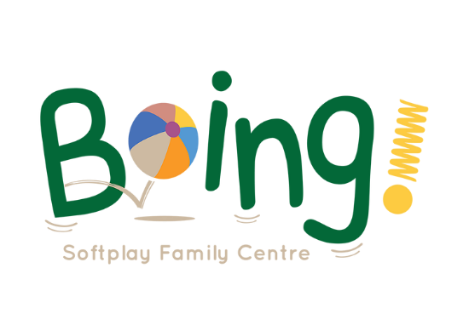

Party Host Recruitment Pack

1. Boing! Party Host Job Advert

2. Job Description

3. Person Specification

4. Application Form (separate document)

Boing! Party Host advert

Boing! Softplay Family Centre has become the party venue of choice for so many families of children aged 0-5 across Bristol. Thanks to the fantastic and affordable Boing! Party offer, and the reviews and testimonials posted by people who have had or attended Boing! Parties, word of mouth has spread across the city and we find ourselves fully booked far in advance.

We are seeking a responsible and capable person to work at Boing! during one of the weekend days, supporting families to run their parties (but not actually running them). As a Party Host you will also be responsible for completing the work in order to manage and increase bookings.

Typically we host six parties every weekend – these need to be split between 3 Party Hosts. The successful candidate for the role will work for 10hrs each weekend - 3 out of every 4 weekends. The new Party Host will also be expected to cover some annual leave and sickness and be a short notice stand-in in case of any emergencies. We are looking for an enthusiastic, hard-worker who is good with, and cares about people, has an eye for detail, is computer literate and strong with administration and can work self-sufficiently, managing systems and processes. The salary for this role will start at £10.50 per hour.

Full training will be provided and as a staff member you will be entitled to benefits including a 50% discount on café food and parties.

If you are interested in finding out more about this role please check out our website, www.boingsoftplay.com or e-mail Hayley at parties@boingsoftplay.com.

Job Description

Job title: Boing! Party Host
Hours of work: 10 hrs per Saturday/Sunday (3 x 10hrs in a 4 week period). More with the cover of annual leave and if asked to work to cover sickness and as a short notice stand-in in case of any emergencies.
Work base: Boing! Softplay Family Centre, c/o The Hub, Gainsborough Square Lockleaze BS7 9FB.
Holiday entitlement: 20 days per year pro rata (plus Bank Holidays).
Salary: Starting at £10.50 per hour (£20,530 per annum pro rata)
Management: Line manager will be the Boing! Party Manager.

Purpose of the post:
- To support families to hold their celebration parties at Boing! including setting up and setting down.
- To ensure that Boing! is clean, tidy and well presented for parties.
- To process Boing! Party enquiries, corresponding with enquirers via e-mail, phone and social media.
- To market Boing!, especially our party offer, and increase the number of Boing! Party bookings.
- To be a fantastic ambassador for Boing!
- To carry out other Boing! administrative tasks including finance database updating and anything else deemed necessary by the Party Manager/CEO.

Further information
Boing! Softplay Family Centre is based in the heart of Lockleaze, a community which, despite recent revitalisation, is still within the top 30% of deprived wards nationally. Boing! was established in 2011 as a part of the important work to support and help some of the community’s more needy families. It is now a social enterprise with all profits ploughed back into the business to help fund our work during the week, which includes a Play Café, a targeted toddlers group and other activities to benefit local families and those from further afield. Our Boing! Parties offer is the income generating part of our enterprise so it is important for us to maximise the number of parties we host.

Every weekend, Boing! can host up to 6 parties, specifically for families of 0-5 year olds – 3 on a Saturday and 3 on a Sunday. Over each of the past 6 months, we have been over 98% full with our party bookings. Many of our bookings come from word-of-mouth (you can see what people are saying about our parties by visiting our Google Review page). Our objective is to fill every available timeslot every weekend.

The party timeslots on a Saturday and Sunday are 9-11.45am, 12.15-3pm and 3.30-6.15pm. These 2hr 45m timeslots must include 30 minutes at the end for setting down the party. There is then a 30 minute buffer until the next party. These six workshifts per weekend will be split between 3 Party Hosts. There can be flexibility around working arrangements and this can be decided once the recruitment has been finalised.

The work for the Party Managers during the parties will look like this:
- 9am/12.15pm/3.30pm: The Party Organiser arrives and is welcomed by the Party Host.
- First 30 minutes of the party: The Party Host helps set up the party. This can involve blowing up balloons, putting up decorations, moving tables and chairs, filling up pump pots with hot water etc.
- Middle 1hr45m: The Party Host will head to the office ready to do some administrative/marketing tasks but will be available to answer any questions from the Party Organiser. The administrative/marketing jobs will involve processing party requests that have come in via e-mail and social media, answering questions, updating our website and social media pages as well as some general office related tasks. The Party Host will walk through Boing! periodically to ensure that rules are being followed and that everything is going well.
- Last 30 minutes: The Party Host helps set down the party, gently moving guests on, clearing and tidying Boing!, and cleaning where necessary, ready for the next party booking.

At the very end of the day the Party Host will need to stay for 45 minutes to complete a deeper clean and tidy of the premises, ready for the next day’s activities.

Person specification

The following criteria are considered essential for this post:
- Demonstration of good organisation and efficiency - ability to manage own workload (including establishing priorities) and work independently (paying attention to detail and being accurate) as well as collaboratively within a limited timescale.
- Proficient in using word processing, spreadsheet and design software (including Microsoft Word, Excel and Publisher).
- Really good administration skills.
- Ability to focus on work when part of a busy office environment.
- The ability and willingness to engage & communicate positively with both children and adults (including face to face, over the phone and via letter, text, social media etc).
- Motivated and hardworking.
- Proactive.
- Reliable.
- Flexible, uses initiative and works well/is creative under pressure.
- Comfortable with responsibility.
- Comfortable with ‘lone’ working.

The following criteria would be desirable:
- Possession of a valid first aid certificate.
- Experience of fundraising.
- Possession of a valid food hygiene certificate.

